Canon imageRUNNER 400 Specifications
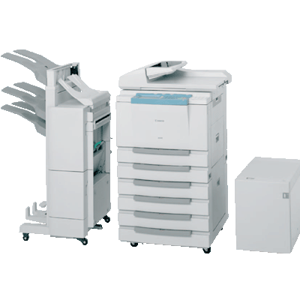

Specifications subject to change without notice.
Pradeep kumar pv
Prdpjumbo@gmail.com
9880988731 9945457636
BANGALORE KARNATAKA
Www. canon.com
Canon INDIA., Inc.

Main Unit
Type : Digital, Multifunction Imaging System
Imaging System: Laser Dry Electrostatic Transfer
Developing System :Dry Monocomponent Toner
Projection
Fixing System : heat roller and pressure roller with web
Image Server Memory :Standard 128MB RAM
HDD (Max. Capacity :Approx.4,000 Originals)
First-copy Time :6.8 Seconds from Platen Glass
6.6 Seconds from ADF
Warm-up Time :10 Seconds or Less From Sleep Mode
29 Seconds from Main Power Off
Copy/Print Speed :40 ppm (Letter)
Actual Resolution :600 dpi x 600 dpi
Interpolated Resolution :200 dpi x 600 dpi (Copy)
Halftone :256 Gradations of Gray
Duplexing :Standard Automatic Trayless Duplexing

Magnification Reduction
Enlargement :25% to 800% (in 1% increments)
Paper Supply
Standard :Dual 500-sheet Paper Cassettes
(1,000 Sheets)
Stack Bypass : (50 Sheets)
Optional :Dual 500-sheet Paper Cassettes
(1,000 Sheets)
Exposure Control :Automatic or Manual
Multiple Copies :1 to 999
Max. Original Size :1" x 17" (Ledger)
Paper Weights :17 lb. to 20 lb. Bond (Cassette)
17 lb. to 32 lb. Bond (Stack Bypass)
Power Source :120V AC, 60Hz, 15A
Drum :OPC—Estimated Yield: 25,000
Impressions
Max. Duty Cycle :120,000 Impressions Per Month
Toner: Estimated Yield : 18,000 Images per KG
Dimensions :H x W x D): 40-1/8" x 22-1/4" x 26-3/4"
(1,020mm x 565mm x 678mm)
Weight :176.3 lb. (90kg)

Specifications subject to change without notice.
Pradeep kumar pv
Prdpjumbo@gmail.com
9880988731 9945457636
BANGALORE KARNATAKA
www. canon.com
Canon INDIA., Inc.

